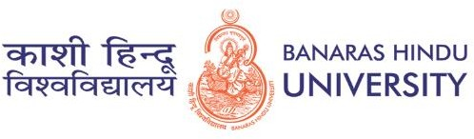

SWARAJ DALUI

[swarajdalui12@gmail.com](mailto:swarajdalui12@gmail.com) |Phone: +91 8697155090 | <https://www.linkedin.com/in/swaraj-dalui-050764227>

ACADEMICS

## M.Sc. Geology, Banaras Hindu University

2020-22 | CGPA – 9.21

## B.Sc. Geology, University of Calcutta Asutosh College

Geology (Hons.) | 2020 | 68.63%

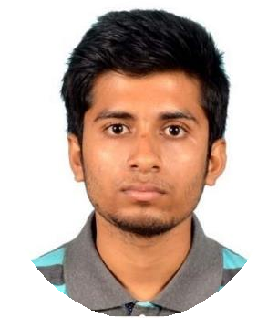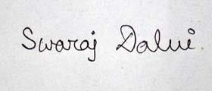

# PERSONAL PROFILE

**Gender:** Male

**Date of Birth:** 26/07/1998 **Address: 68 Balitikuri Bamun Para HOWRAH -711113**

# CERTIFICATIONS

* Natural Hazards
* Remote Sensing and GIS
* Information Technology Application

# SOFT SKILLS

* Team work and flexibility
* Analytical ability
* Keen observation skills

# TECHNICAL SKILLS

* MS Office
* ArcGIS
* Sarproz

# HOBBIES

* Playing and watching football and table tennis
* Music and Guitar
* Travelling

# LANGUAGES

* Bengali
* English
* Hindi
* **Schooling**
* Hindu School, Kolkata: 12th | 2016 | WBCHSE | 86.2%
* Hindu School, Kolkata: 10th | 2014 | WBBSE | 88.3%

WORK EXPERIENCE

## Freshers

* + - **Geological Fieldwork Experiences**
      * **General Geology Fieldwork in Mython, West Bengal**

Context; Geological Location Determination; Hand specimen study; Sedimentary structures identification; General mineral Identification (like quartz, feldspar); Dam Visit; Metamorphic rock study

* + - * **Structural Geology Fieldwork in Ghatsila and Galudih, Jharkhand Context; Geological Mapping, Fold Interference Pattern Identification in Tentuldanga; Sedimentary structure Identification.**
      * **Economic Geology Fieldwork in Joda, Barbil, Noamundi; Jharkhand Context; Mine Visit; KJC Ahluwalia Iron Ore Mines, Tata Iron Ore Mines in Joda, Noamundi. Manganese Mine visit**
      * **Geophysical Fieldwork in Southern Sikkim**

Context; Resistivity Survey to delineate major earthquake prominent zone.

INTERNSHIPS & PROJECTS

## Dissertation

**Subject: Remote Sensing and GIS Supervisor: Dr. Ashwani Raju**

**Project Title**: **Detecting slow moving landslides in parts of Southern Sikkim: Using Persistent Scatterer Interferometry (PSI)**

ACHIEVEMENTS & POSITIONS OF RESPONSIBILITY

* + IIT-JAM 2020 Qualified
  + GATE 2022 Qualified
  + Former Geological field organizer at Department of GEOLOGY, Asutosh College

EXTRA-CURRICULAR ACTIVITIES

* + Participate in College Football Tournament
  + Participate in Badminton Tournament
  + Participate in University Rangoli Competition

## Signature